Used ls and cd commands, created a directory “pandey” using mkdir pandey

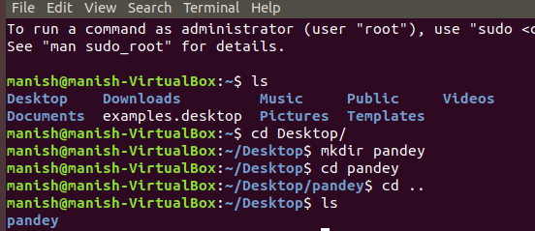

Created a file manishh using vi manishh and inserted content. Renamed the file as “mpandey”

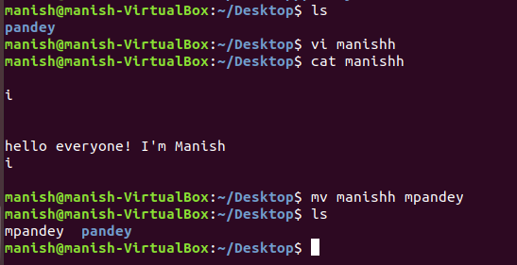

History

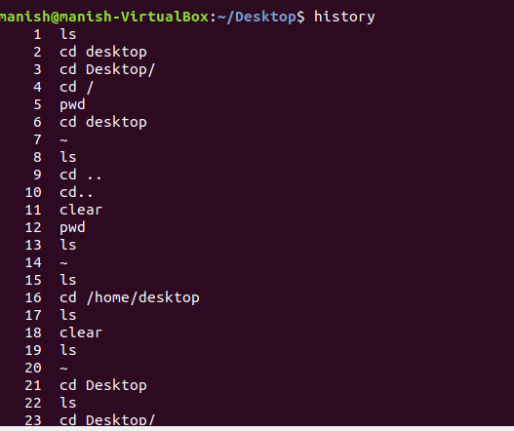

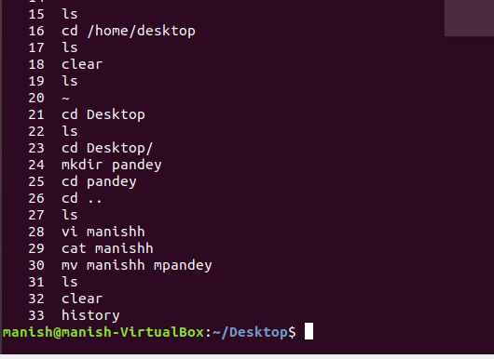

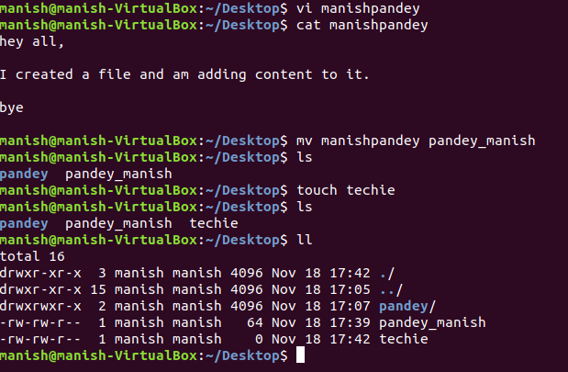

**LINUX COMMANDS PART 02**

Changed permissions to manish using chmod 777 manish

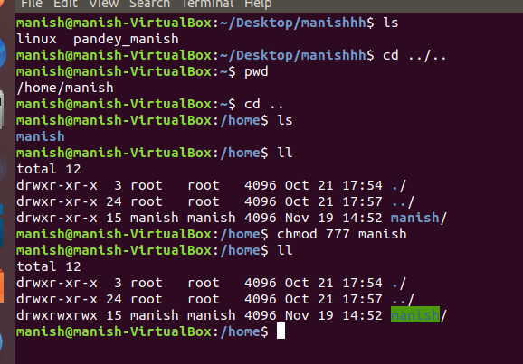

Changed permissions to manish back to as it was using chmod 755 manish

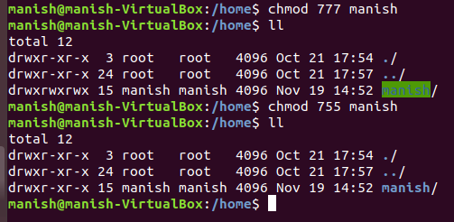

Changed owner of the directory manish to root using “**sudo chown root:root manish**” and then changed back the owner from root to manish using **“sudo chown manish:manish manish"**

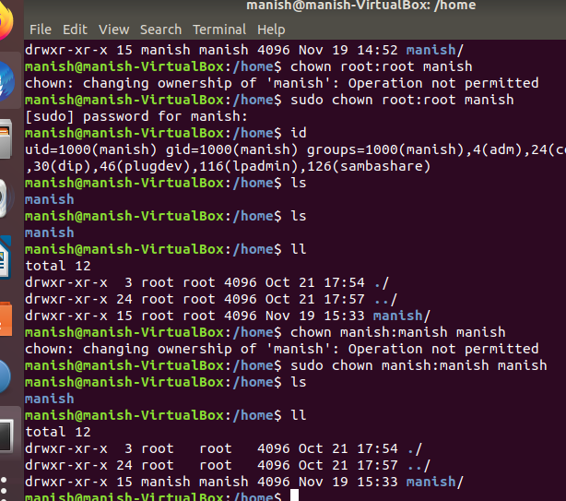

Switched to root user using **sudo su –** and switched back to user manish using **su manish**

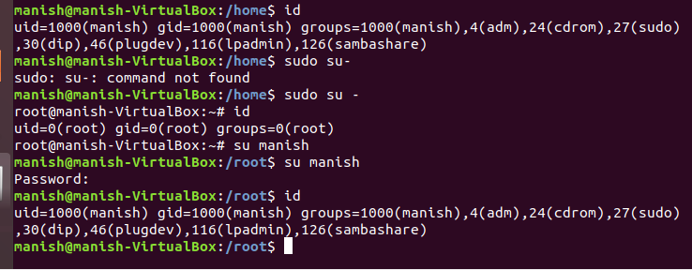

Created user mike using **useradd mike** and switched to user mike using **su mike**

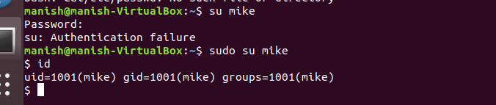

Used double redirection to add content to file linux

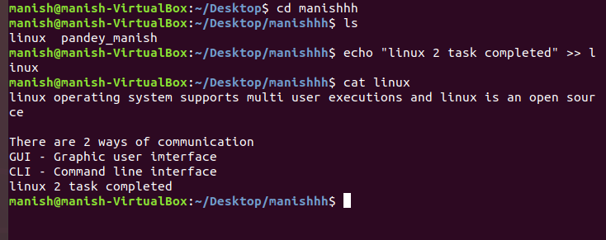

Used  **grep** command to find a keyword command used **grep completed task**

